

MAWLANA BHASHANI SCIENCE AND TECHNOLOGY UNIVERSITY

Santosh,Tangail-1902

**LAB REPORT**

Lab Report No : 04

Lab Report name :File Operation and permission.

Course Title :Operating System Lab

Course Code :ICT-3110

Date of Performance :

Date of Submission : 28/9/2020

Submitted by,

Name : Farhana Afrin Shikha

ID :IT-18038

Session : 2017-18

3rd Year 1stsemester

Dept. of ICT

Submitted to,

Nazrul Islam

Assistant Professor

Dept. of ICT,

MBSTU.

**Lab 04 : File operation and permission**

**Objectives:**

**i. File operation ii. File permission**

**File Operation :** To use the Linux terminal like a pro, we’ll need to know the basics of managing files and navigating directories.Differnet file operation is given below…

**1.ls –** List Files The ls command lists the files in a directory. By default, ls lists files in the current directory.

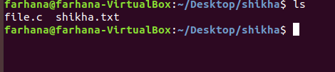

**2. cd** – Change Directory The cd command changes to another directory. For example, cd Desktop will take you to your Desktop directory if you’re starting from your home directory.

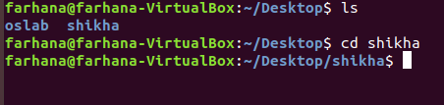

**3) mkdir** – Make Directories The mkdir command makes a new directory. mkdir example will make a directory with the name “example” in the current directory.

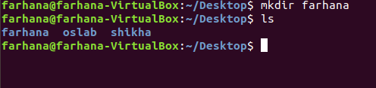

**4.rmdir** – Remove Directories The rmdir command removes an empty directory. rmdir directory would delete the directory named “directory” in the current directory.

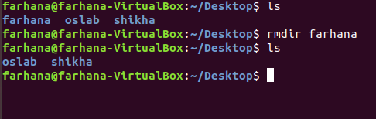

**5.** we can also list files recursively — that is, list all files in directories inside the current directory — with ls -R.

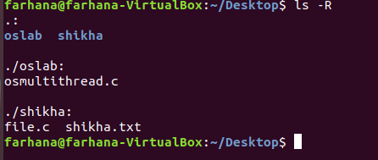

**6. cd . .** will take you up a directory.

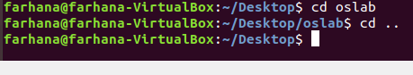

**File operation:**

**There are 3 types of permissions:**

1) Read

2) Write

3) Execute permission

Read (r): this gives permission to merely open a file or folder and view its contents.

Write (w): this gives permission to overwrite, append-to or delete a file or folder.

Execute (x): this gives permission to "run" a file. For example to run a script or a program.

So, how can we put this all into context? Let's have a look at the contents of a typical folder. I used the command ls -l to bring up this list:

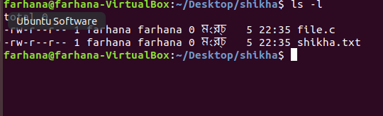

we can also do this via the command-line. Go to a directory that has files in it and type the following command to view all files in a list:

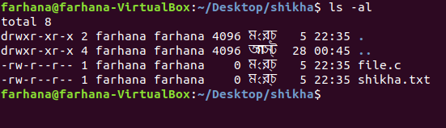

To change a file or directory’s permissions, let’s look at the basic form of the chmod command.

chmod [class][operator][permission] file

chmod [ugoa][+ or –] [rwx] file

u: This is for the owner.

g: This is for the group. o: This is for all others. a: This will change permissions for all of the above.

+: The plus sign will add the permissions which follow.

-: The minus sign will remove the permissions which follow.

r: Allows read access.

w: Allows write access. x: Allows execution.

Conclusion:File operation is an important topic in linux operating system.If I have ever tried my hand in shell scripting ,it should be aware of the use of mkdir and touch to create directories and empty file and if I want to give a file some meaningful content,I can use vim or nano.Apart from these basic operations,there are several other operations,removing file or derectories,copying,renaming or creating shortcuts.Copying file on linux is really simple:cp command is used.After copying some file in our home directory we are left with a littke mess.Instead of only creating files,lets use the rm command to remove some duplicate items.Sometimes we do not just want to create or delete a file,we might need to rename one.Weirdly linux does not have anything that sounds like rename;however the mv command does accomplish th functionality that we want.Similarly to the cp command it takes a source file and destination file as argument. Linux divides the file permission into read,write and execute denoted by r,w and x.The permission on a file can be changed by ‘chmod’ command which can be further divided into absolute and symbolic mode.